Western Blot
Acrylamide Gel Preparation

- First of all you have to make sure the glass plates are conventionally cleaned with soap and water (a final wash with ethanol might be advisable).
- Place the glass plates in the pouring stand making sure they are pushed all the way to the bottom before tightening the screws. If the assembly is correct the the whole set-up should snap into place when placed above the gray gasket.
- Insert the glass plate sandwich in the casting stand.
- Use 200 µL of water to make sure the structure is tight enough to contain the gel.
- Gel mixture for 10% acrilamide gel (depends on the proteins you want to separate, see pages 5 and 6).

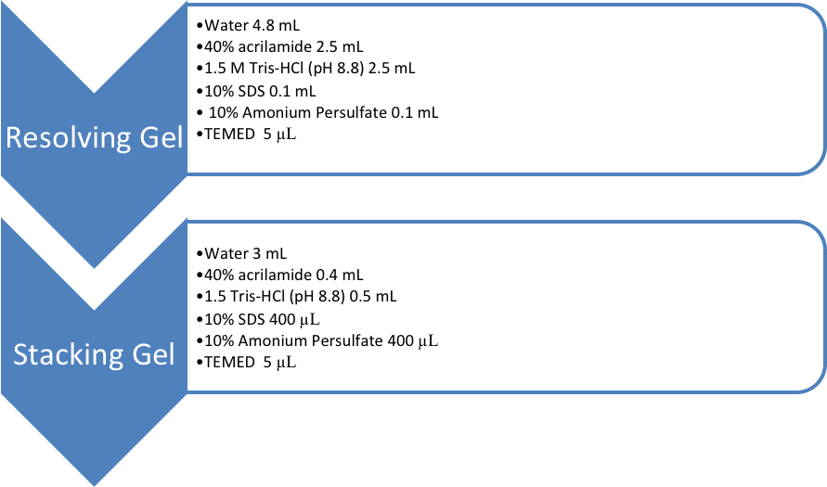

  - Mix every component of the resolving gel (make sure the last ones are the ammonium persulfate or the TEMED otherwise you will have a premature polymerization). Pour resolving gel to fill the space between the glass plates.
  - On top of resolving gel mixture (before it polimerizes) fill the compartment between the glasses with water. Leave it until polymerization occurs. Remove water before adding the stacking gel.
  - Mix the components of the stacking gel. Pour stacking gel to fill the remaining space between the glass plates.
  - Insert comb and let polymerize (this takes 10-15 minutes).

Electrophoretic Separation:

- Before starting prepare the running buffer.
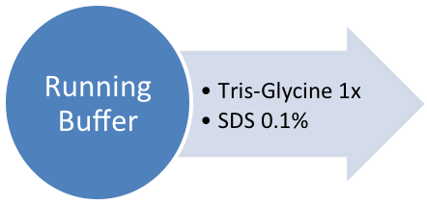

- Place gel in holder/electrode, then transfer to running tank.
- Fill with 1X Running Buffer (keep inside and outside buffer chambers separated).
- Add a little bit of 1x loading buffer to each well to help define the well space. This will also help with detecting small pieces of polyacrylamide that might be plugging up any wells or SDS that might formed a dense bed. In general this will not affect the separation, although they will reduce the volume that can be loaded. The wells must be cleaned with a syringe (very important!).
- Load samples previously boiled with 1x loading buffer.
- Run at 100V through the stacking gel
- Run at 150V through until the dye front reaches the bottom of the gel.
Blotting
- Before starting prepare the Transfer Buffer and the Wash Buffer with and without milk.
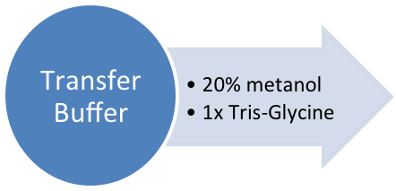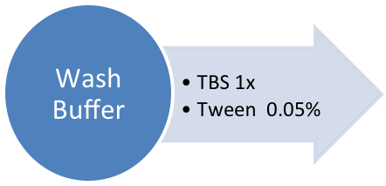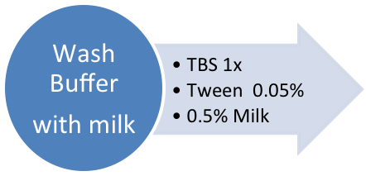

- Cut off stacking gel and nick top left-hand corner of resolving gel for orientation.
- Transfer gel, while still attached to glass plate, to a box containing transfer buffer, peel off gently with a spatula.
- Cut a piece of PVDF membrane to the size of the gel and immerse it respectively in methanol; water; transfer buffer.
- Cut 4 filter pieces of 3MA paper and immerse them with the two fiber pads in transfer buffer.
- Open a gel holder cassette in a plastic container, black side up and hinges to the left and below the white side.
- Soak a fiber pad with Transfer Buffer and place in the center of the white side.
- Soak two pieces of filter paper with Transfer Buffer and place on top of the fiber pad.
- Putt the gel on top of the filter paper followed by the PVDF membrane and two more filters.
- Remove bubbles rolling a falcon tube on top of the filters.
- Add another fiber pad and close the holder cassette.
- Place it in a transfer tank (black side of the cassette to the red side of the electrode). Include the ice bucket and cover the tank with ice. It is advisable to keep the transfer buffer in the cold room a couple of hours before use.
- Run 1 hour at 100V (in 4ºC room).

Immunodetection

- Following Western Blot transfer check that the stained markers have been transferred to the membrane.
- Place the membrane in a box containing Wash Buffer +milk, 1 hour at room temperature or overnight at 4°C.
- Remove the medium and add the 1st antibody (at the appropriate dilution in Wash buffer + milk). Leave it for 2 hours at room temperature or overnight at 4°C.
- Wash with Wash Buffer + milk twice for 10 minutes.
- Wash with Wash Buffer twice for 10 minutes.
- Add the 2nd antibody (dilution 1:1000 in Wash buffer) and incubate it for 1 hour at room temperature.
- Wash three times with Wash Buffer, 10 minutes each wash.
- Add ECL-Plus detection solution (3mL of each detection solution, mix before add to the membrane) and incubate it for 1 minute moving the container with your hand and making sure the membrane is fully submerged in the solution.
- Wick off excess detection fluid and place membrane inside a page protector or non-fluorescent plastic inside an autoradiography cassette including little markets of fluorescence that will enable you to see the gel direction.
- Autoradiograph with 1 minute exposition. Try to improve the time in accord with the amount of sample you have.

Resolving Gel.
10 mL Gel | 6% | 8% | 10% | 12% | 15%
Water [mL] | 5.8 | 5.3 | 4.8 | 4.3 | 3.5
40% Acrylamide  [mL] | 1,5 | 2.0 | 2.5 | 3.0 | 3.8
1.5 M Tris HCl  [mL] | 2.5 | 2.5 | 2.5 | 2.5 | 2.5
10% SDS  [µL] | 100 | 100 | 100 | 100 | 100
10% Amonium Persulfate  [µL] | 100 | 100 | 100 | 100 | 100
TEMED  [µL] | 5 | 5 | 5 | 5 | 5

Stacking Gel.
4 mL Gel | 4%
Water [mL] | 3.0
40% Acrylamide  [µL] | 400
1.5 M Tris HCl  [µL] | 500
10% SDS  [µL] | 40
10% Amonium Persulfate  [µL] | 40
TEMED  [µL] | 5

